|  |  |
| --- | --- |
| EGC_Black | **MATHEMATICS:SPECIALIST 1 & 2**  **SEMESTER 1 2015**  **TEST 3**  **Resource Free** |

Time Allowed: 24 minutes Total Marks: 19

**1.** [1, 3 marks]

A

B

C

D

A line drawn from a point A forms a tangent to a circle at B. A second line from A cuts through the same circle at point C and D.

(a) State a relationship between the lengths of the line segments AB, AD and AC.

(b) Hence prove that ΔABD ~ ΔACB.

**2.** [3, 1 marks]

Given vectors **m** = 5**i** – 2**j** and **n** = 4**i** + 3**j**, determine

(a) the scalar projection of **m** onto **n**.

(b) the vector projection of **m** onto **n**.

**3.** [6 marks]

O

A

B

C

M

Prove that the diagonals of a parallelogram bisect each other.

OABC is a parallelogram with $\vec{\text{OA}}$ = **a** and $\vec{\text{OC}}$ = **c**. The diagonals OB and AC meet at M.

If $\vec{\text{AM}}$ = h $\vec{\text{AC}}$ and $\vec{\text{OM}}$ = k $\vec{\text{OB}}$, use the fact that $\vec{\text{OM}}=\vec{\text{OA}}+\vec{\text{AM}}$ to show that h = k = ½.

**4.** [1, 1, 3 marks]

(a) Find a counter-example to show that the following conjecture is not true.

$∀ a, b ∈ Z$ and $a>b$ then $a^{2}>b^{2}$

(b) Find an example to show that the following conjecture is true.

$∃ a∈Q$ such that $\frac{12}{a}∈Z$

(c) Write the mathematical notation for the statement:

*For all rational numbers x, there exist integers y and w such that 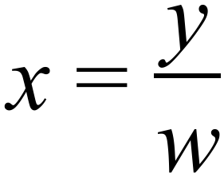 where w is non-zero.*

|  |  |
| --- | --- |
| EGC_Black | **MATHEMATICS:SPECIALIST 1 & 2**  **SEMESTER 1 2015**  **TEST 3**  **Calculator Assumed** |

Time Allowed: 27 minutes Total Marks: 22

**5.** [2 marks]

The work done, in joules, by a force of  Newtons in changing the displacement of an object by  metres is given by the scalar product of  and .

A force acting on a bearing of 160º does work of 1 200 joules. If the object moved a distance of 350 cm on a bearing of 135º, determine the magnitude of the force. (2 marks)

**6.** [2, 4 marks]

B

O

140°

A

C

D

*b*

*d*

(a) A circle centred at O has s∠AOC = 140°, as shown in the diagram. Determine the values of *b* and *d*. Justify your answers.

55°

S

T

O

x°

A

B

C

D

(b) A circle centred at O has a tangent ST as shown in the diagram. Given that s∠CDT = 55°, determine the value of x. Justify your answer.

**7.** [5 marks]

O

A

B

C

**a**

**b**

Prove that if the diagonals of a rectangle are perpendicular then the rectangle is a square.

O

A

B

C

X

Y

**b**

**a**

**8.** [2, 3 marks]

OABC is a parallelogram, X is the midpoint of AB and Y is such that $\vec{\text{CY}}$ = $\frac{\text{2}}{\text{3}}\vec{\text{CB}}$.

Let $\vec{\text{OA}}$ = **a** and $\vec{\text{OC}}$ = **b**.

(a) Express $\vec{\text{OX}}$ and $\vec{\text{OY}}$ in terms of **a** and/or **b**.

(b) Show that $\vec{\text{OX}}$• $\vec{\text{OY}}$ = $\frac{\text{4}}{\text{3}}$**a**•**b** + 8, given ⎪**a**⎪ = 3 and ⎪**b**⎪ = 2.

9. [4 marks]

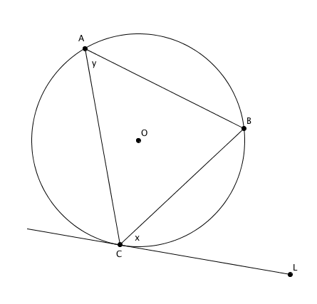In the diagram, CL is a tangent to a circle with centre O at C.

Angle BCL = *x*  and

Angle CAB = *y.*

Prove that *x* = *y*